**Task 11:Comparing Methods of Gas Exchange**

**Science Inquiry Total Marks: 30**

**Conditions: In class validation. Students may use their hand written practical report.**

**Time for Task: 30 minutes**

**Weighting: 4%**

**1 Label the following diagram (5 marks)**

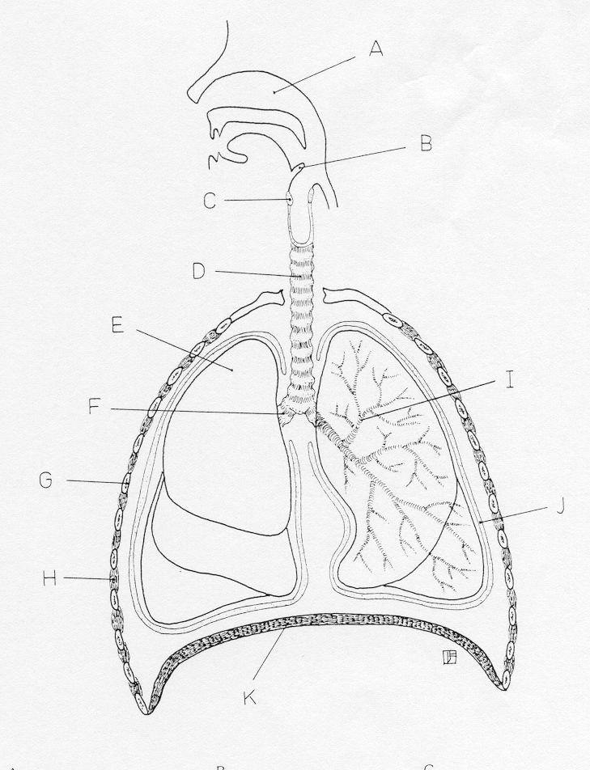

**A______________________________ F____________________________**

**I_______________________________ K____________________________**

**G______________________________**

1. **Describe the structure of the trachea. What feature of the trachea prevent it from collapsing? (2 marks)**

**____________________________________________________________________________________________________________________________________________________________________________________________________________________________________________**

**3 Label the following diagram (5 marks)**

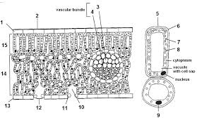**11____________________________________**

**12____________________________________**

**10____________________________________**

**14____________________________________**

**15____________________________________**

1. **Through what structure does gas exchange occur in a plant?**

**(1 mark)**

**_____________________________________________**

1. **Explain how an oxgen molecule from outside a leaf would become present in cells type 14. (5 marks)**

**______________________________________________________________________________________________________________________________________________________________________________________________________________________________________________________________________________________________________________________________________________________________________________________________________________________________________________________________________________________________________________________________________________________________________________**

1. **Explain why a fish out of water dies from lack of oxygen, even though the concentration of oxygen in air is more than four times that of water?**

**(4 marks)**

**______________________________________________________________________________________________________________________________________________________________________________________________________________________________________________________________________________________________________________________________________________________________________________________________________________________________________________________________________________________________________________________________________________________________________________**

**List the features of an efficient respiratory surface. Explain the importance of each feature. (8marks)**

**________________________________________________________________________________________________________________________________________________________________________________________________________________________________________________________________________________________________________________________________________________________________________________________________________________________________________________________________________________________________________________________________________________________**